**Session report 14/02/2023:**

*LABAUVIE – RAFFAELLI EVA*

*ROB3*

This session’s goal I went back to the buckets parts.

After discussing with Xavier when I printed the wheel, he advised me not to pierce holes to fix the buckets so I will try to create a sustem that goes and fixes itself around the structure.

I started by adding a structure that would go around the axis :

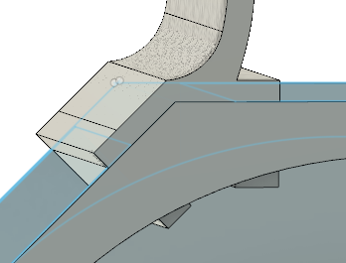

And I added a fillet inside the bucket because it would make the sand less likely to get stucked inside.

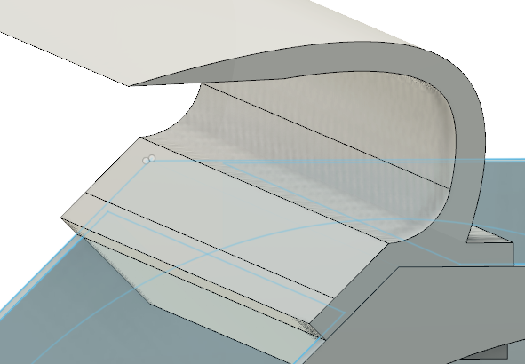

I made a systema to screw a rectangle and secure the whole bucket attach.

